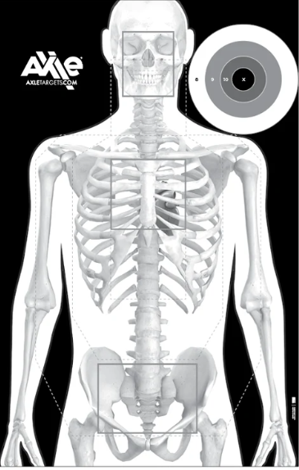
Target #5 - - - Rifle/SBR - - - Rounds: _____ Time: _______
Distance & Par Time (Goal): Circle your choice:
12 yds (1/2 sec) / 15 yds (1 sec) / 17 yds (1.5 sec)
Distance : 20 yds (No Time)
Name: __________________________________________ Month: __________

